**Taaha Hussain Khan**

**L1F21BSCS0917**

**Task 01:**

#include <stdio.h>

#include <stdlib.h>

#include <pthread.h>

struct ThreadArgs {

    char *name;

    int reg_number;

};

void *printInfo(void *args) {

    struct ThreadArgs *info = (struct ThreadArgs *)args;

    printf("Name: %s\nRegistration Number: %d\n", info->name, info->reg_number);

    pthread_exit(NULL);

}

int main() {

    pthread_t tid;

    struct ThreadArgs args;

    args.name = "Taaha Hussain Khan";

    args.reg_number = 917;

    if (pthread_create(&tid, NULL, printInfo, (void *)&args) != 0) {

        fprintf(stderr, "Failed to create thread\n");

        return 1;

    }

    if (pthread_join(tid, NULL) != 0) {

        fprintf(stderr, "Failed to join thread\n");

        return 1;

    }

    return 0;

}

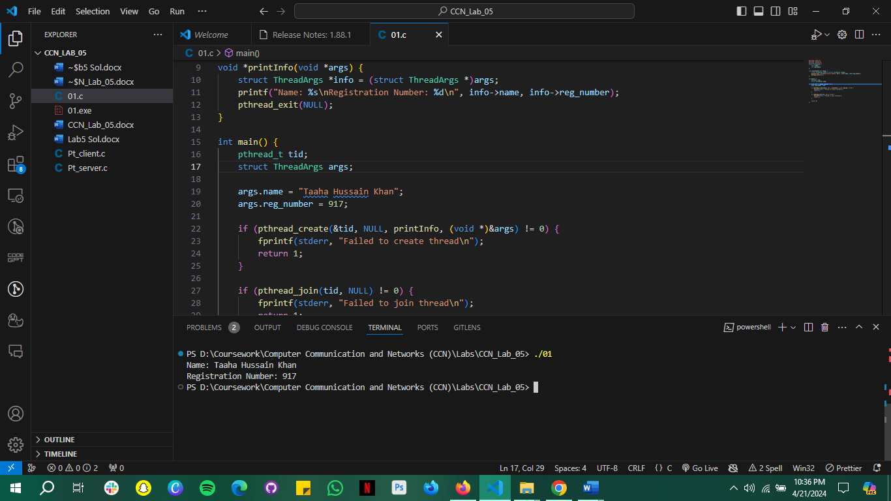

**Task 2:**

#include <stdio.h>

#include <stdlib.h>

#include <pthread.h>

struct ThreadArgs {

    char *name;

    int reg_number;

};

void *printInfo(void *args) {

    struct ThreadArgs *info = (struct ThreadArgs *)args;

    printf("Name: %s\nRegistration Number: %d\n", info->name, info->reg_number);

    pthread_exit(NULL);

}

int main() {

    pthread_t tid;

    struct ThreadArgs args;

    args.name = "Taaha Hussain Khan";

    args.reg_number = 917;

    if (pthread_create(&tid, NULL, printInfo, (void *)&args) != 0) {

        fprintf(stderr, "Failed to create thread\n");

        return 1;

    }

    if (pthread_join(tid, NULL) != 0) {

        fprintf(stderr, "Failed to join thread\n");

        return 1;

    }

    return 0;

}

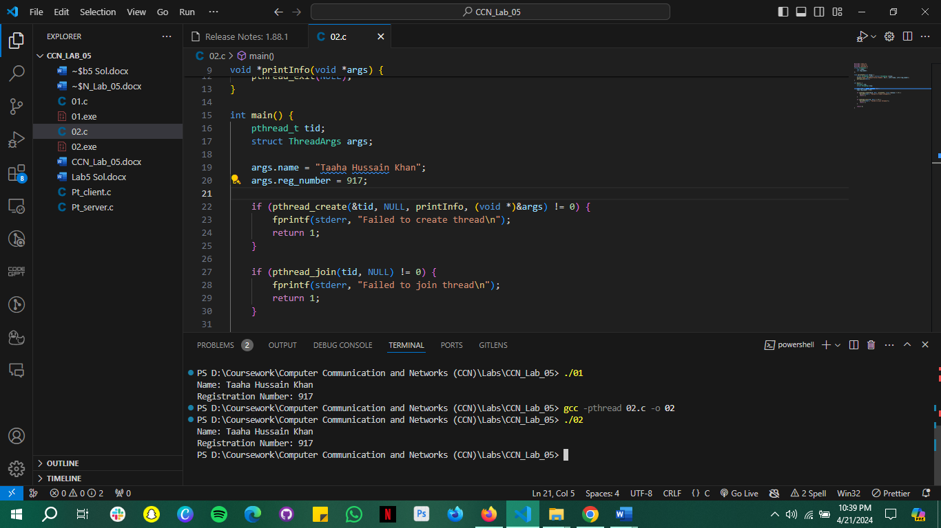

**Task 3**

**Server:**

**#include <stdio.h>**

**#include <stdlib.h>**

**#include <string.h>**

**#include <unistd.h>**

**#include <pthread.h>**

**#include <sys/socket.h>**

**#include <netinet/in.h>**

**#define PORT 8080**

**#define MAX_CLIENTS 10**

**#define MAX_FILES 3**

**char *files[MAX_FILES] = {"file1.txt", "file2.txt", "file3.txt"};**

**void *handleClient(void *arg) {**

**int client_socket = *((int *)arg);**

**char buffer[1024] = {0};**

**struct sockaddr_in addr;**

**socklen_t addr_size = sizeof(struct sockaddr_in);**

**getpeername(client_socket, (struct sockaddr *)&addr, &addr_size);**

**char ip_address[INET_ADDRSTRLEN];**

**inet_ntop(AF_INET, &addr.sin_addr, ip_address, INET_ADDRSTRLEN);**

**int port = ntohs(addr.sin_port);**

**sprintf(buffer, "IP Address: %s\nPort: %d\n", ip_address, port);**

**send(client_socket, buffer, strlen(buffer), 0);**

**memset(buffer, 0, sizeof(buffer));**

**sprintf(buffer, "Available files:\n");**

**for (int i = 0; i < MAX_FILES; i++) {**

**strcat(buffer, files[i]);**

**strcat(buffer, "\n");**

**}**

**send(client_socket, buffer, strlen(buffer), 0);**

**memset(buffer, 0, sizeof(buffer));**

**recv(client_socket, buffer, 1024, 0);**

**FILE *file = fopen(buffer, "r");**

**if (file == NULL) {**

**send(client_socket, "File not found", strlen("File not found"), 0);**

**} else {**

**while (fgets(buffer, sizeof(buffer), file) != NULL) {**

**send(client_socket, buffer, strlen(buffer), 0);**

**memset(buffer, 0, sizeof(buffer));**

**}**

**fclose(file);**

**}**

**send(client_socket, "Do you want to download more files? (Yes/No): ", strlen("Do you want to download more files? (Yes/No): "), 0);**

**recv(client_socket, buffer, 1024, 0);**

**if (strcmp(buffer, "Yes\n") == 0) {**

**handleClient(arg);**

**}**

**close(client_socket);**

**pthread_exit(NULL);**

**}**

**int main() {**

**int server_socket, client_socket;**

**struct sockaddr_in server_addr, client_addr;**

**pthread_t tid;**

**int opt = 1;**

**server_socket = socket(AF_INET, SOCK_STREAM, 0);**

**if (server_socket == -1) {**

**perror("Socket creation failed");**

**exit(EXIT_FAILURE);**

**}**

**if (setsockopt(server_socket, SOL_SOCKET, SO_REUSEADDR | SO_REUSEPORT, &opt, sizeof(opt))) {**

**perror("Setsockopt failed");**

**exit(EXIT_FAILURE);**

**}**

**server_addr.sin_family = AF_INET;**

**server_addr.sin_addr.s_addr = INADDR_ANY;**

**server_addr.sin_port = htons(PORT);**

**if (bind(server_socket, (struct sockaddr *)&server_addr, sizeof(server_addr)) < 0) {**

**perror("Bind failed");**

**exit(EXIT_FAILURE);**

**}**

**if (listen(server_socket, MAX_CLIENTS) < 0) {**

**perror("Listen failed");**

**exit(EXIT_FAILURE);**

**}**

**while (1) {**

**socklen_t addr_size = sizeof(struct sockaddr_in);**

**client_socket = accept(server_socket, (struct sockaddr *)&client_addr, &addr_size);**

**if (client_socket < 0) {**

**perror("Accept failed");**

**exit(EXIT_FAILURE);**

**}**

**pthread_create(&tid, NULL, handleClient, (void *)&client_socket);**

**}**

**close(server_socket);**

**return 0;**

**}**

**Client:**

**#include <stdio.h>**

**#include <stdlib.h>**

**#include <string.h>**

**#include <unistd.h>**

**#include <sys/socket.h>**

**#include <netinet/in.h>**

**#include <arpa/inet.h>**

**#define PORT 8080**

**int main() {**

**int client_socket;**

**struct sockaddr_in server_addr;**

**char buffer[1024] = {0};**

**client_socket = socket(AF_INET, SOCK_STREAM, 0);**

**if (client_socket == -1) {**

**perror("Socket creation failed");**

**exit(EXIT_FAILURE);**

**}**

**server_addr.sin_family = AF_INET;**

**server_addr.sin_port = htons(PORT);**

**if (inet_pton(AF_INET, "127.0.0.1", &server_addr.sin_addr) <= 0) {**

**perror("Invalid address/ Address not supported");**

**exit(EXIT_FAILURE);**

**}**

**if (connect(client_socket, (struct sockaddr *)&server_addr, sizeof(server_addr)) < 0) {**

**perror("Connection failed");**

**exit(EXIT_FAILURE);**

**}**

**recv(client_socket, buffer, 1024, 0);**

**printf("%s\n", buffer);**

**memset(buffer, 0, sizeof(buffer));**

**recv(client_socket, buffer, 1024, 0);**

**printf("%s\n", buffer);**

**memset(buffer, 0, sizeof(buffer));**

**printf("Enter file name to download: ");**

**fgets(buffer, sizeof(buffer), stdin);**

**send(client_socket, buffer, strlen(buffer), 0);**

**FILE *file = fopen("downloaded_file.txt", "w");**

**while (recv(client_socket, buffer, 1024, 0) > 0) {**

**fputs(buffer, file);**

**memset(buffer, 0, sizeof(buffer));**

**}**

**fclose(file);**

**close(client_socket);**

**return 0;**

**}**